NAME______________________________DATE___________________PERIOD________

ALGEBRA 1 REVIEW #4 FOR SPRING SEMESTER EXAM

Graph the inequalities below and shade the solution.
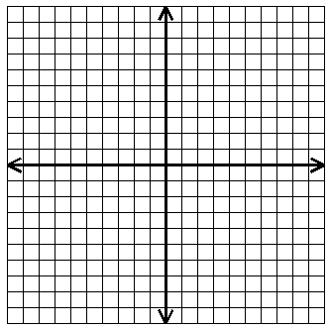
1. y > ½ x - 4

2. y > -2x + 3
y x + 1

- Circle the following points that are in the solution set of problem #2.

(-5,-6) (0,0) (4,-1) (0,8) (8,0)

Simplify the following problems.
- (-3x⁴)(4x³) = _________________ | 5. (8x⁶)(2x⁴) – (5x²)(5x⁸) = ________
- (x - 5)(x – 7) = ______________ | 7. (4x – 3)(3x + 3) = _____________
8. 4t(2t² – t – 5) = ______________ | - 2x²y(2x² – 3xy + y²) = _____________
- (-4c³)³ = ____________ | 11. (4x²y)²(-3xy²)³ = ____________
6a
a
9a
12. Find the volume of this solid.

V ___________________

Simplify.
13. 21a⁻⁵bc⁹ =  14abc ____________ | 14. 4c³d =  12cd ______________
FACTOR COMPLETELY.
15. 18x – 12y + 36 _____________ | 16. 81x⁴ – 16y⁶ _______________
17. -4x² - 8x + 5 ______________ | 18. 2r² + 7r +5 ________________
19. 4p² + 7p – 2 _______________ | 20. $10x^{2}+31x+15$ ______________
21. $xy^{4}-16x$ _______________ | 22. $4x^{3}y-4x^{2}y-8xy$ _____________

What are the solutions.
23. (n - 5)(n + 8) = 0 _____________________________

24. (3x + 1)(2x + 5) = 0 _____________________________

25. x² + 6x + 8 = 0 ____________________________

26. 5a² - 14a = 8 _____________________________

Solve using the Quadratic Formula. Round your answers to the nearest tenth.
27. 6x² – 5x – 2 = 0

Answers: ____________________

28. x² - 10x + 24 = 0 a = ______ b = ______ c = ______

Answers: ____________________

29. 2x² = -5 – 11x a = ______ b = ______ c = ______

Answers: ____________________

30. Find the missing factor: 56p⁷q⁸ = (2pq⁴)(4pq)__?__

ANSWER: ________

Write the equation for the parabola: y = x²
31. Shifts down 4 units and more narrow ANSWER: __________________

32. Make parent function wider and facing down ANSWER: _________________

33. At which points does the graph of f(x) = 4x² + 8x – 2 intersect the x-axis?

34. For the function y = 4x² + 3x – 1, what is the value of y when x = -5?

35. What is the vertex of y = 4x² + 3x – 1?

40. EVALUATE: where a = -8, b = -5, and c = 6.

